**Project Initialization and Planning Phase**

| Date | 08 July 2024 |
| --- | --- |
| Team ID | SWTID1720076203 |
| Project Name | Anemia Sense: Leveraging Machine Learning For Precise Anemia Recognitions |
| Maximum Marks | 3 Marks |

**Define Problem Statements (Customer Problem Statement Template):**

Anemia remains a widespread and underdiagnosed condition, particularly in rural and underserved areas, due to outdated and inefficient diagnostic and management methods. Patients often experience delayed detection, generalized treatment plans, and the necessity for frequent in-person visits. These issues result in suboptimal care, increased healthcare costs, and significant patient dissatisfaction. The current approach fails to provide timely, personalized, and continuous care, exacerbating the condition's impact on patients' health and quality of life. Addressing these challenges is crucial for improving patient outcomes and overall satisfaction with anemia management.

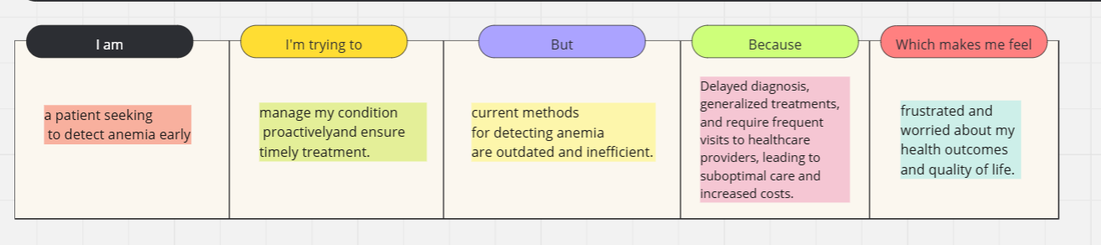

|  |  |  |  |  |  |
| --- | --- | --- | --- | --- | --- |
| **Problem**  **Statement (PS)** | **I am**  **(Customer)** | **I’m trying to** | **But** | **Because** | **Which makes me feel** |
| PS-1 | a patient seeking to detect anemia early. | manage my condition proactively and ensure timely treatment. | current methods for detecting anemia are outdated and inefficient. | delayed diagnosis, generalized treatments, and require frequent visits to healthcare providers, increased costs. | frustrated and worried about my health outcomes |